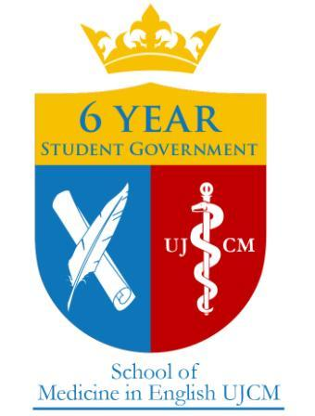
6 Year Student Government Academic Grant & Student Initiative Funding Program Information Sheet
The 6 Year Student Government (6YSG) reserves the right to issue grants for worthwhile academic and social causes. Applicants are to write a formal request and meet with the 6YSG to discuss the purpose of the grant and its projected impact. 6YSG grants may be used for academic, social, or sports related initiatives or any initiative for the betterment of the student experience at the School of Medicine in English UJ CM. Grants shall be approved by a vote of 6YSG after reviewing the application.
________________________________________________________________________________
All students interested in applying for funding from 6YSG should read the list of requirements necessary below and submit their application no later than Tuesday, February 28th, 2017. Applications should be submitted to 6YSG via email at 6ystudentgovernment@gmail.com.
Each organization must have a representative attend and present their proposal in person at the grant proposal meeting on March 4th, 2017 at the CDK, at 13:00. Room to be announced.
Additional questions may also be directed to the 6YSG Treasurer, Jens Arnesen, via email: jens.arnesen@gmail.com.
Requirements for applications:
- Must contain a formal request in the form of a letter, explaining the purpose and logistics of the requested grant, as well as a proposed budget.
- Students who are involved, and number of students affected.
- What this grant can be used for:
  - Venue rentals, covering direct transportation costs, purchasing equipment/supplies.
  - Direct payment of vendors’ faktura VAT.
- No exclusion of students:
  - i.e. If you are requesting funding for a guest lecturer, the lecture must be presented in English.

Additional information:
- 6YSG requires full financial transparency and requires acknowledgment of funding on promotional materials.
- Full amount requested may not be granted, and full funds requested MUST be spent by December 31, 2016.
- If an organization which has been approved for a grant fails to meet one of the requirements within the fiscal year, 6YSG has the right to revoke the remaining funds.
- Each organization must have a representative attend and present their proposal in person at the grant proposal meeting on March 4th, 2017 at CDK, at 13:00, room TBA.
- Grant approval is subject to ratification by the members of the 6 Year Student Government.

